Creation is a Rational Order
Key Verse
Psalm 19: 1-6
The heavens proclaim the glory of God. The skies display his craftsmanship.
Day after day they continue to speak; night after night they make him known.
They speak without a sound or word; their voice is never heard.
Yet their message has gone throughout the earth, and their words to all the world.
God has made a home in the heavens for the sun. It bursts forth like a radiant bridegroom after his wedding. It rejoices like a great athlete eager to run the race.
The sun rises at one end of the heavens and follows its course to the other end.
Nothing can hide from its heat.
John 1: 1-3
In the beginning the Word (LOGOS) already existed. The Word (LOGOS) was with God,
and the Word (LOGOS) was God. He existed in the beginning with God.
God created everything through him, and nothing was created except through him.
--What is the announcement it is display in creation day after day, and night after night?
--Who can see it or hear it and who can´t?
--Creation possesses a God´s given order, what kind of order is it?
--Can human beings measure, explore, and to understand creation? Why?
--What benefit produces this attribute of man?
Hebrew 11:3
By faith we understand that the worlds were prepared by the word of God, so that what is seen was made from things that are not visible.
Psalm 147: 15-18
He sends His command throughout the earth; His word runs swiftly. He spreads snow like wool, He scatters frost like ashes; He throws His hailstones like crumbs.
Who can withstand His cold? He sends His word and melts them;He unleashes His winds, and the waters flow.
Colossians 1: 17
He is before all things, and by Him all things hold together.
--How is the universe constructed? How does Hebrews 11:3 definition works?
--Modern people call them natural laws, how did the psalmist called it?
--According to his ¨biblical¨ understanding, how the creation worked?
--Why are ¨natural laws¨ rational and IMMUTABLE?
--When we study the natural order of the universe, what are we really studying?
Romans 1: 19-25
¹⁹ What can be known about God is clear to them because he has made it clear to them. ²⁰ From the creation of the world, God’s invisible qualities, his eternal power and divine nature, have been clearly observed in what he made. As a result, people have no excuse. ²¹ They knew God but did not praise and thank him for being God. Instead, their thoughts were pointless, and their misguided minds were plunged into darkness. ²² While claiming to be wise, they became fools. ²³ They exchanged the glory of the immortal God for statues that looked like mortal humans, birds, animals, and snakes.
²⁴ For this reason God allowed their lusts to control them. As a result, they dishonor their bodies by sexual perversion with each other. ²⁵ These people have exchanged God’s truth for a lie. So they have become ungodly and serve what is created rather than the Creator, who is blessed forever. Amen!
--How did the Romans reject God? Name the two things they didn´t do
--How do we praise God when we see His glory in creation? Johannes Kepler
--How do we thank God when we perceive His glory in creation?
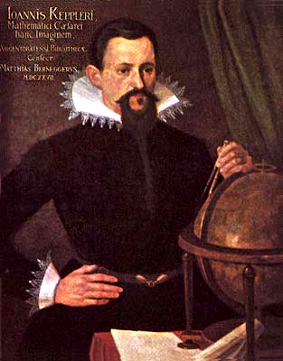--What happens when we reject God’s rationality?

Since we astronomers are priests of the highest God in regard to the book of nature, it befits us to be thoughtful, not of the glory of our minds, but rather, above all else, of the glory of God.

